Practical 29 :

Code :

import java.awt.\*;

import java.applet.\*;

public class Poly extends Applet

{

 int a1[]={20, 120, 220, 20};

 int b1[]={20, 120, 20, 20};

 int n1=4;

 int a2[]= {120, 220, 220, 120};

 int b2[]= {120, 20, 220, 120};

 int n2=4;

public void paint(Graphics g)

{

 g.drawPolygon(a1,b1,n1);

 g.fillPolygon(a2,b2,n2);

}

}

Output :

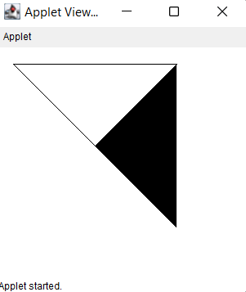

Code : Output :

import java.applet.\*;

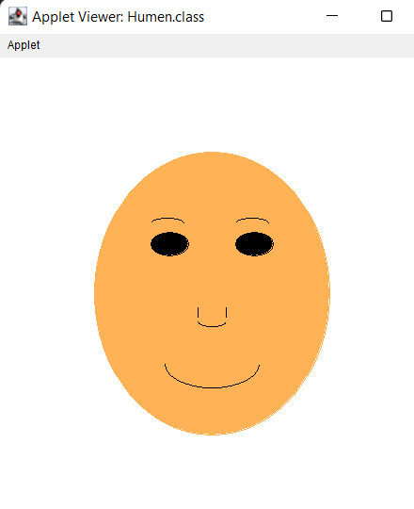import java.awt.\*;

public class Humen extends Applet

{

    //Initialize the applet

    public void init()

    {

    setBackground(Color.white);

    }

      public void paint(Graphics g)

    {

        Color clr=new Color(255,179,86);

        g.setColor(clr);

        g.drawOval(100,100,250,300);

        g.fillOval(100,100,250,300);

        g.setColor(Color.black);

        g.drawOval(160,185,40,25);

        g.fillOval(160,185,40,25);

        g.drawOval(250,185,40,25);

        g.fillOval(250,185,40,25);

        g.drawArc(160,170,35,10,0,180);

        g.drawArc(250,170,35,10,0,180);

        g.drawLine(210,265,210,275);

        g.drawLine(240,265,240,275);

        g.drawArc(210,275,30,10,0,-180);

        g.drawArc(175,300,100,50,0,-180);

    }

}

Code :

import java.awt.\*;

import java.applet.\*;

public class Arcs extends Applet{

public void paint(Graphics g){

g.drawArc(10,40,70,70,0,75);

 g.fillArc(100,40,70,70,0,75);

  g.drawArc(10,100,70,80,0,175);

   g.fillArc(100,100,70,90,0,270);

   g.drawArc(200,80,80,80,0,180);

}

}

Output :

